yomelelani damane
damaneyomelelani@gmail.com
51942437

COMPUTER SCIENCE
Ditiro-Financial-Services-Taung

MILESTONE TWO
This project involved the design and implementation of a segmented enterprise network using Cisco Packet Tracer. The network was designed to support multiple departments while separating departmental traffic into dedicated VLANs.
A Cisco Catalyst 3560 multilayer switch was used as the core Layer 3 device to provide inter-VLAN routing, while three Cisco Catalyst 2960 switches were used as access switches. A router was connected to the core switch through a routed point-to-point link.
Network security was implemented using Access Control Lists (ACLs), including Guest network isolation and controlled access to the server network. Secure SSH management was also configured for the access switches, and unused switch ports were hardened by placing them into an unused VLAN and administratively shutting them down.
Project Objectives
The objectives of the project were to:
- Design a structured enterprise network topology.
- Segment departments using VLANs.
- Configure Layer 3 inter-VLAN routing.
- Configure 802.1Q trunk links between switches.
- Implement network security using ACLs.
- Isolate the Guest network from internal networks.
- Restrict access to the Server VLAN.
- Configure a dedicated Management VLAN.
- Configure secure SSH access to network switches.
- Harden unused switch ports.
- Configure static routing between the core switch and router.
- Test and verify end-to-end network connectivity.
- Troubleshoot configuration and connectivity problems encountered during implementation.
Network Requirements
The network was designed to support the following departments and infrastructure services:
- Administration
- Finance
- Human Resources
- IT
- Guest
- Server
- Network Management
Each department was assigned a separate VLAN and subnet. The network was designed so that authorised departments could access the server while Guest users were prevented from accessing internal networks.
Network devices were assigned management addresses on a dedicated Management VLAN and configured for secure SSH administration.

Network Topology
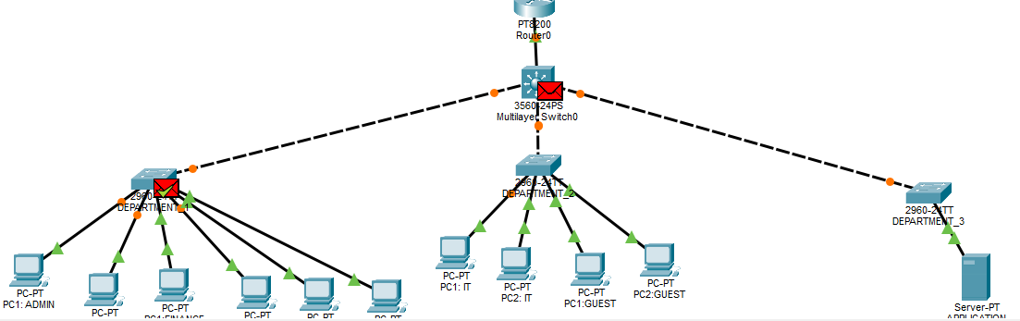
The topology consists of one Cisco Catalyst 3560 multilayer core switch, three Cisco Catalyst 2960 access switches, one router, departmental end devices, Guest devices, and a dedicated server.
The Catalyst 3560 provides Layer 3 routing between VLANs and connects to the router using a routed point-to-point link. The three access switches provide connectivity to departmental end devices and connect to the core through 802.1Q trunk links.
Device Inventory
Core Network
- Cisco Catalyst 3560 Layer 3 Core Switch
- Cisco Router
Access Layer
- Cisco Catalyst 2960 SW1
- Cisco Catalyst 2960 SW2
- Cisco Catalyst 2960 SW3
End Devices
- 2 Administration PCs
- 2 Finance PCs
- 2 HR PCs
- 2 IT PCs
- 2 Guest PCs
- 1 Server
VLAN Design
VLAN 10 — Administration
- VLAN ID: 10
- VLAN Name: ADMINISTRATION
- Network: 192.168.15.0/27
- Gateway: 192.168.15.1
- PC1: 192.168.15.2
- PC2: 192.168.15.3
VLAN 20 — Finance
- VLAN ID: 20
- VLAN Name: FINANCE
- Network: 192.168.15.32/27
- Gateway: 192.168.15.33
- PC1: 192.168.15.34
- PC2: 192.168.15.35
VLAN 30 — HR
- VLAN ID: 30
- VLAN Name: HR
- Network: 192.168.15.64/27
- Gateway: 192.168.15.65
- PC1: 192.168.15.66
- PC2: 192.168.15.67
VLAN 40 — IT
- VLAN ID: 40
- VLAN Name: IT
- Network: 192.168.15.96/27
- Gateway: 192.168.15.97
- PC1: 192.168.15.98
- PC2: 192.168.15.99
VLAN 50 — Guest
- VLAN ID: 50
- VLAN Name: GUEST
- Network: 192.168.15.128/27
- Gateway: 192.168.15.129
- PC1: 192.168.15.130
- PC2: 192.168.15.131
VLAN 60 — Server
- VLAN ID: 60
- VLAN Name: SERVER
- Network: 192.168.15.160/27
- Gateway: 192.168.15.161
- Server: 192.168.15.162
VLAN 70 — Management
- VLAN ID: 70
- VLAN Name: MANAGEMENT
- Network: 192.168.15.192/27
- Gateway: 192.168.15.193
- Core SVI: 192.168.15.193
- SW1: 192.168.15.194
- SW2: 192.168.15.195
- SW3: 192.168.15.196
Router-to-Core Transit Network
A dedicated /30 transit network was used between the multilayer core switch and the router.
- Network: 192.168.15.224/30
- Core 3560 Fa0/4: 192.168.15.225
- Router Gi0/0/0: 192.168.15.226
- Broadcast: 192.168.15.227
Fa0/4 on the Catalyst 3560 was converted into a routed interface using no switchport. The router interface was assigned the corresponding point-to-point address. Connectivity between the two devices was verified using ICMP ping tests.
Physical and Logical Port Assignments
SW1
- Fa0/1 → Administration PC1 → VLAN 10
- Fa0/2 → Administration PC2 → VLAN 10
- Fa0/3 → Finance PC1 → VLAN 20
- Fa0/4 → Finance PC2 → VLAN 20
- Fa0/5 → HR PC1 → VLAN 30
- Fa0/6 → HR PC2 → VLAN 30
- Fa0/7 → Core uplink → Trunk
SW2
- Fa0/1 → Core uplink → Trunk
- Fa0/2 → IT PC1 → VLAN 40
- Fa0/3 → IT PC2 → VLAN 40
- Fa0/4 → Guest PC1 → VLAN 50
- Fa0/5 → Guest PC2 → VLAN 50
SW3
- Fa0/1 → Core uplink → Trunk
- Fa0/2 → Server → VLAN 60
- Fa0/3 → IT device → VLAN 40
- Fa0/4 → Guest PC1 → VLAN 50
- Fa0/5 → Guest PC2 → VLAN 50
VLAN Configuration
Figure 2: VLAN Configuration
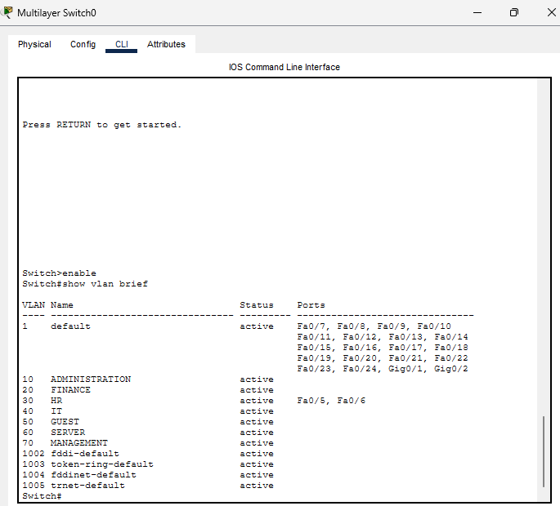
The show vlan brief command was used to verify VLAN creation and access-port membership.
Core Switch Configuration
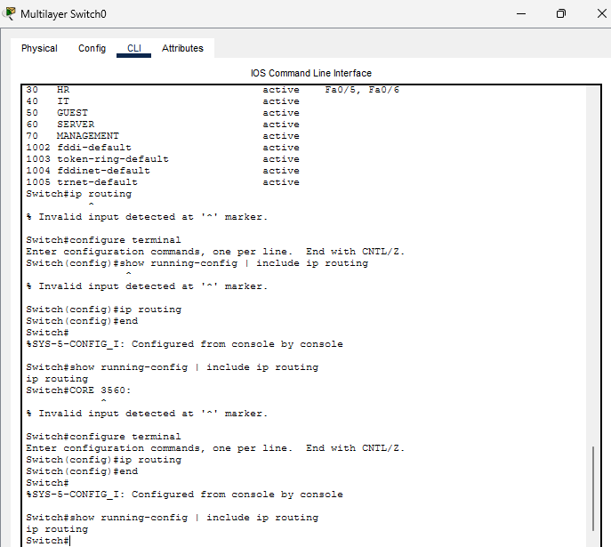
ip routing enabled Layer 3 forwarding on the Catalyst 3560 and allowed the switch to route between VLAN interfaces.
SVI Configuration
interface Vlan10
ip address 192.168.15.1 255.255.255.224

interface Vlan20
ip address 192.168.15.33 255.255.255.224

interface Vlan30
ip address 192.168.15.65 255.255.255.224

interface Vlan40
ip address 192.168.15.97 255.255.255.224

interface Vlan50
ip address 192.168.15.129 255.255.255.224

interface Vlan60
ip address 192.168.15.161 255.255.255.224

interface Vlan70
ip address 192.168.15.193 255.255.255.224
Trunking and Spanning Tree
802.1Q trunking was configured between the Catalyst 3560 core switch and the three Catalyst 2960 access switches. VLANs 10, 20, 30, 40, 50, 60 and 70 were permitted across the trunk links.
VLAN 1 was used as the native VLAN on the trunk links. Native VLAN consistency was verified on both ends of the switch-to-switch connections.
Spanning Tree Protocol using PVST was used to prevent Layer 2 loops in the redundant switching topology.
These following commands were used:
show interfaces trunk
show spanning-tree
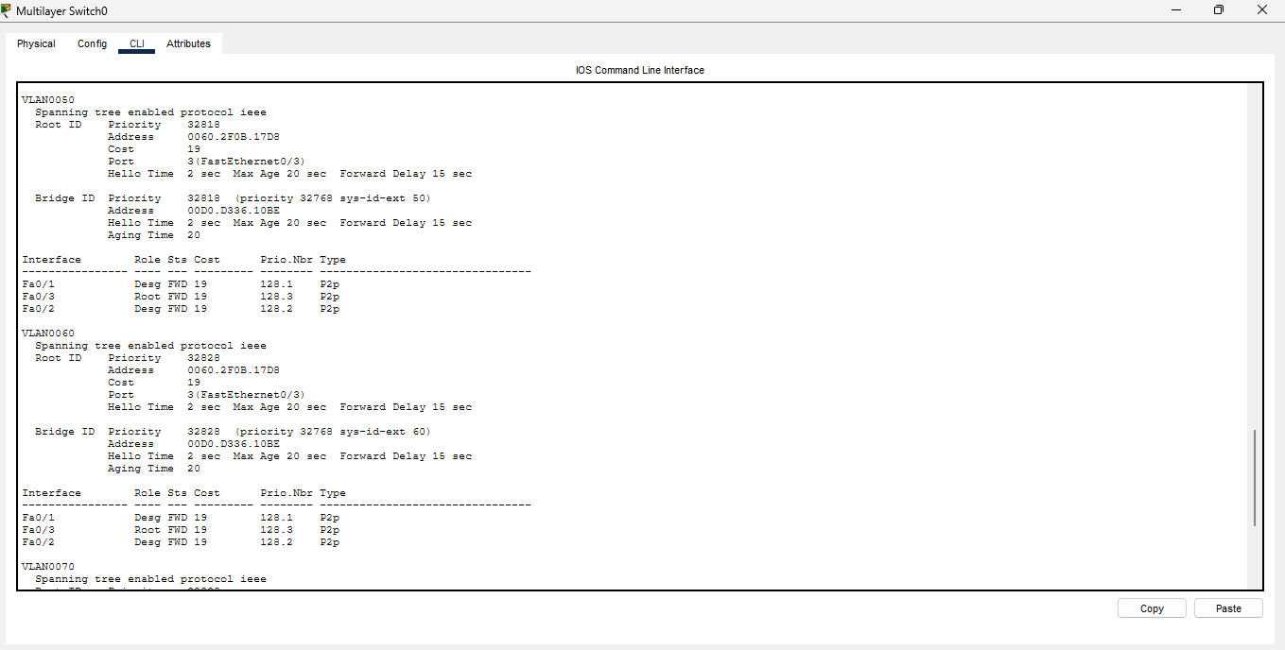
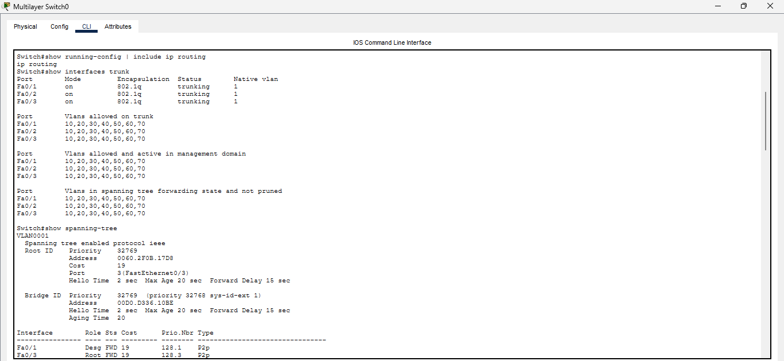
Inter-VLAN Routing
Inter-VLAN routing was provided by the Catalyst 3560 using Switch Virtual Interfaces. Each VLAN was assigned a gateway address, allowing devices in different VLANs to communicate when permitted by the configured security policies.
Connectivity to the VLAN gateways was successfully tested from the departmental PCs.
- Administration → 192.168.15.1
- Finance → 192.168.15.33
- HR → 192.168.15.65
- IT → 192.168.15.97
- Guest → 192.168.15.129
Routing Configuration
The Catalyst 3560 was configured with a default route pointing toward the router.
ip route 0.0.0.0 0.0.0.0 192.168.15.226
The router was configured with static routes for all internal VLAN networks through 192.168.15.225.
routes
192.168.15.0/27
192.168.15.32/27
192.168.15.64/27
192.168.15.96/27
192.168.15.128/27
192.168.15.160/27
192.168.15.192/27
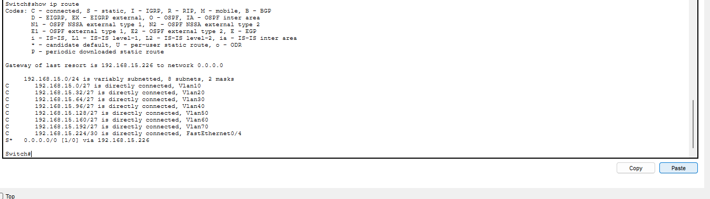
Security Architecture
Network security was implemented using VLAN segmentation and extended Access Control Lists.
The main security controls were:
- Guest network isolation
- Server access control
- Dedicated Management VLAN
- SSH for secure remote administration
- Unused-port shutdown
- Unused-port VLAN assignment
These controls were designed to reduce unnecessary network exposure and limit communication between network segments.
Guest Network Isolation
Guest devices were placed in VLAN 50 and isolated from the internal 192.168.15.0/24 network.
ACL:
ip access-list extended GUEST_RESTRICTION
deny ip 192.168.15.128 0.0.0.31 192.168.15.0 0.0.0.255
permit ip any any
Applied to VLAN 50:
interface Vlan50
ip access-group GUEST_RESTRICTION in
The first ACL statement denies IP traffic sourced from the Guest subnet to the internal 192.168.15.0/24 network. The second statement permits other IP traffic.
This command was used:
show ip access-lists GUEST_RESTRICTION
Server Protection
The server is located in VLAN 60 at 192.168.15.162.
Access to the server was explicitly permitted from Administration, Finance, HR and IT. Traffic from other sources was denied.
ACL:
ip access-list extended SERVER_PROTECTION
permit ip 192.168.15.0 0.0.0.31 host 192.168.15.162
permit ip 192.168.15.32 0.0.0.31 host 192.168.15.162
permit ip 192.168.15.64 0.0.0.31 host 192.168.15.162
permit ip 192.168.15.96 0.0.0.31 host 192.168.15.162
deny ip any host 192.168.15.162
permit ip any
Applied this command:
interface Vlan60
ip access-group SERVER_PROTECTION out
This configuration allows the four authorised departmental networks to reach the server while blocking other sources.
SSH Management
SSH version 2 was configured on the access switches to provide secure remote management.
Each access switch was assigned a management IP address on VLAN 70.
List:
- SW1: 192.168.15.194
- SW2: 192.168.15.195
- SW3: 192.168.15.196
Configuration:
ip domain-name network.local
username admin password <REDACTED>
crypto key generate rsa
ip ssh version 2

line vty 0 4
login local
transport input ssh
this command was used:
show ip ssh
Figure 5: SSH Management
Switch Hardening
Unused switch ports were moved to VLAN 999 and administratively disabled. This prevents unused physical interfaces from remaining active and reduces the risk associated with unauthorized device connections.
SSH was used for secure remote management and login banners were configured on the switches.
Configuration:
vlan 999
name UNUSED_PORTS
interface range FastEthernet0/8 - 24 switchport mode access switchport access vlan 999 shutdown
Router Configuration
The router was connected to the Catalyst 3560 through the 192.168.15.224/30 transit network.
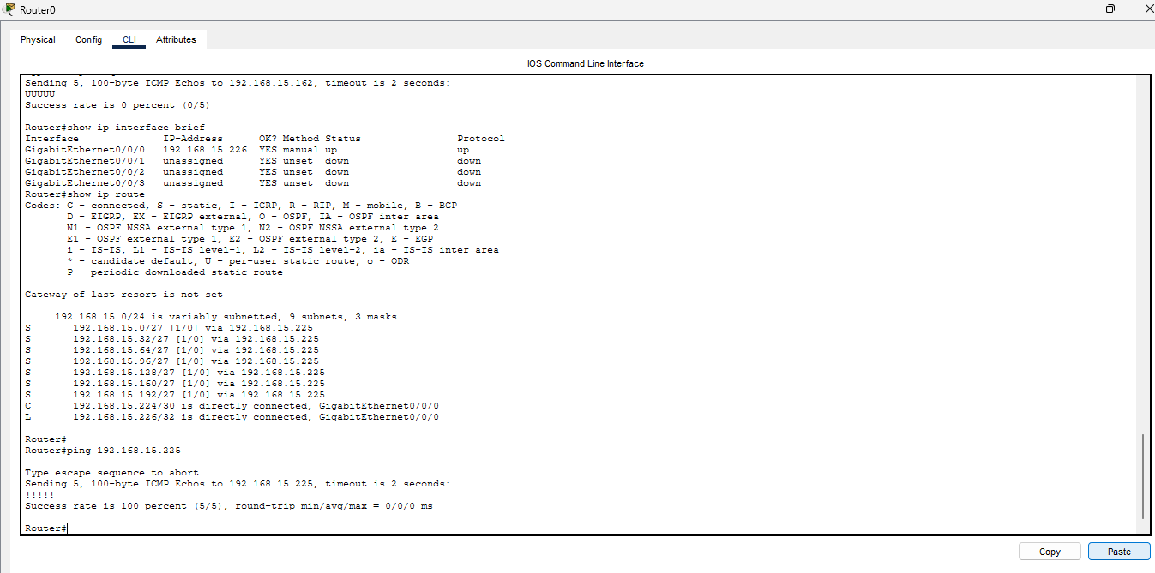
Router interface:
interface GigabitEthernet0/0/0
ip address 192.168.15.226 255.255.255.252
no shutdown
Static routes:
ip route 192.168.15.0 255.255.255.224 192.168.15.225
ip route 192.168.15.32 255.255.255.224 192.168.15.225
ip route 192.168.15.64 255.255.255.224 192.168.15.225
ip route 192.168.15.96 255.255.255.224 192.168.15.225
ip route 192.168.15.128 255.255.255.224 192.168.15.225
ip route 192.168.15.160 255.255.255.224 192.168.15.225
ip route 192.168.15.192 255.255.255.224 192.168.15.225
Testing and Verification
Gateway connectivity was tested from end devices in each VLAN.
Administration
ping 192.168.15.1
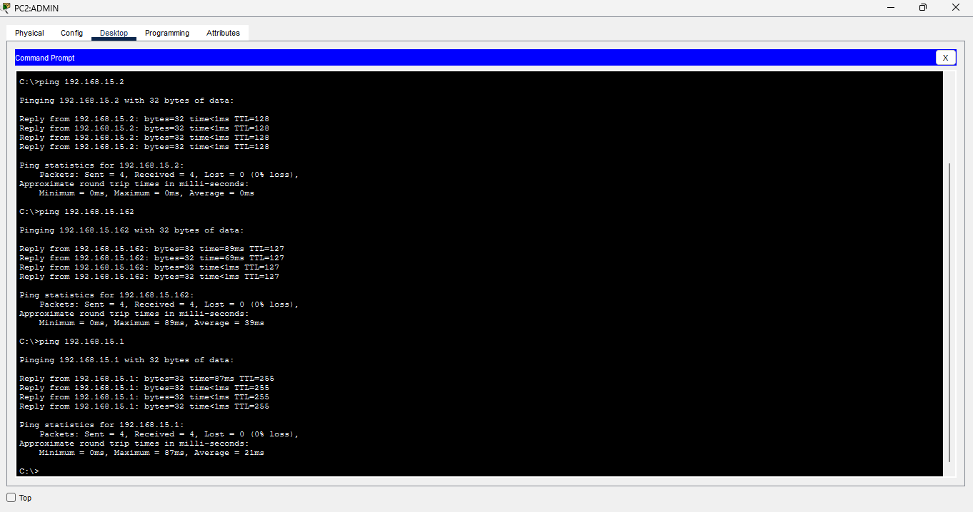
Result: Successful
Finance
ping 192.168.15.33
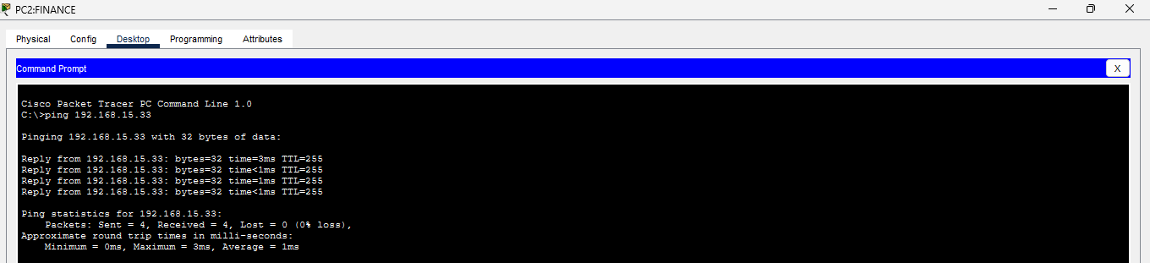
Result: Successful
HR
ping 192.168.15.65
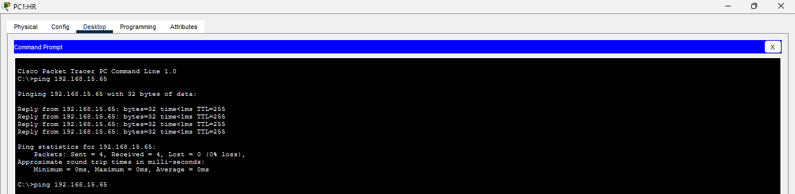
Result: Successful
IT
ping 192.168.15.97
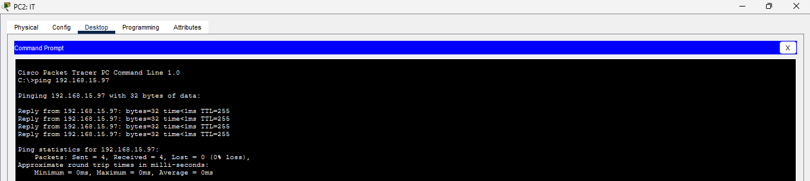
Result: Successful
Guest
ping 192.168.15.129
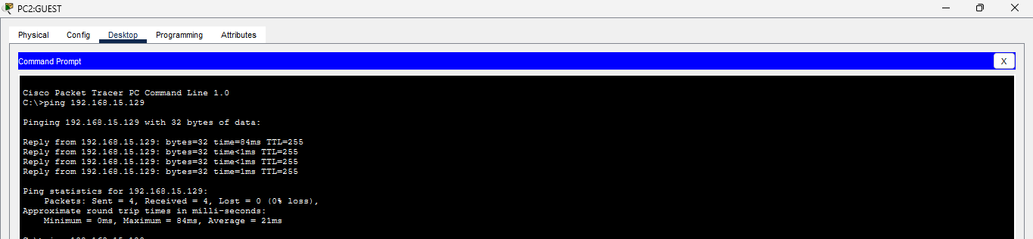
Result: Successful

Server Connectivity Tests
Server connectivity was verified from the authorised departmental VLANs.
- Administration → 192.168.15.162 → Successful
- Finance → 192.168.15.162 → Successful
- HR → 192.168.15.162 → Successful
- IT → 192.168.15.162 → Successful
- Security Verification
Security policies were validated using connectivity tests and ACL hit counters.
Guest Isolation
- Guest → Server → Blocked
- Guest → Internal network → Blocked
Server Protection
- Administration → Server → Allowed
- Finance → Server → Allowed
- HR → Server → Allowed
- IT → Server → Allowed
- Unauthorised sources → Server → Blocked
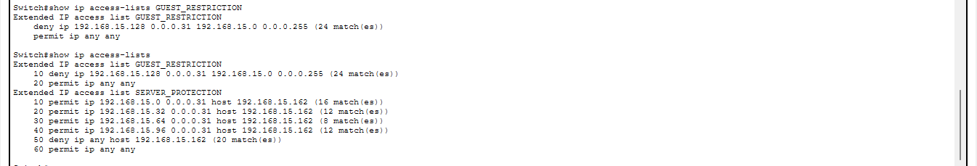
Figure 6: ACL Security Evidence
Management Connectivity Tests
Management connectivity was verified using VLAN 70.
Tests included:
- ping 192.168.15.193
- ping 192.168.15.194
- ping 192.168.15.195
- ping 192.168.15.196
Successful communication between the core switch and the access-switch management addresses confirmed that VLAN 70 was being carried across the required trunk links.
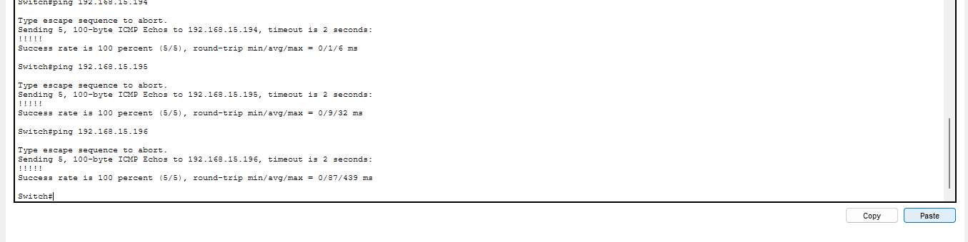
SSH Verification
SSH connectivity was tested from an Administration PC to each access switch.
Tests:
ssh -l admin 192.168.15.194
ssh -l admin 192.168.15.195
ssh -l admin 192.168.15.196
Results:
- SW1 → Successful
- SW2 → Successful
- SW3 → Successful
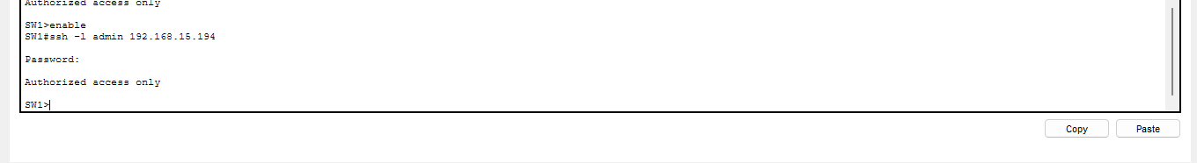
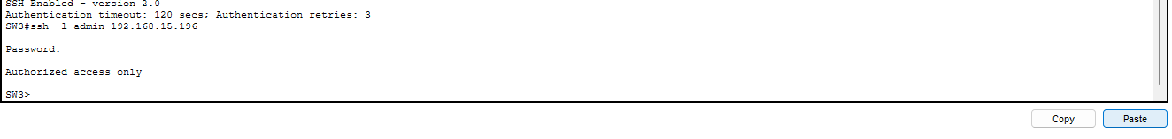

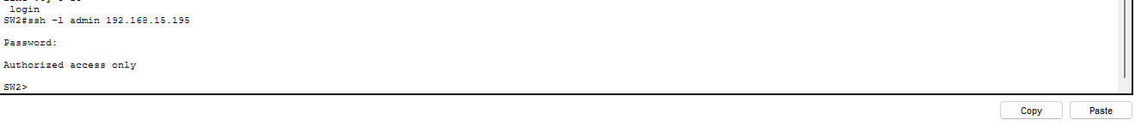
Troubleshooting and Resolutions
Issue 1: Native VLAN Mismatch
%CDP-4-NATIVE_VLAN_MISMATCH.
This was due to having different native vlans amongst the switches. Department1 had native vlan was 1, department2 had native vlan 10 and department3 was native vlan 1. I had to change these native vlans to 1 across the switches.
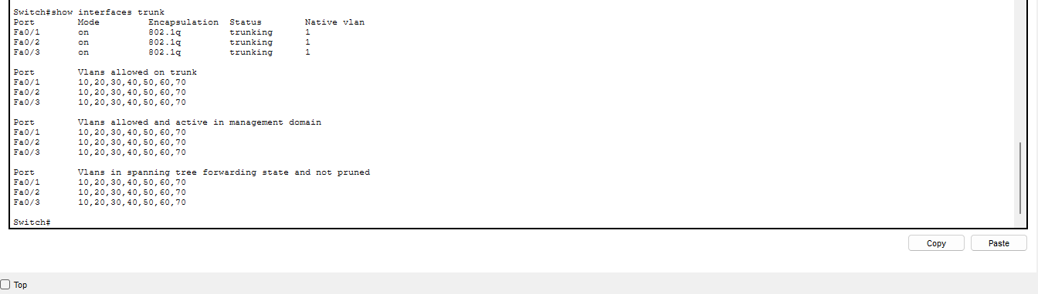

Issue 2: Incorrect Access/Trunk Port Configuration
During troubleshooting, some interfaces intended for end devices had been configured as trunk ports. This prevented normal untagged end-device traffic from being handled as expected.
Resolution:
switchport mode access
switchport access vlan <VLAN-ID>
Verification:
show interfaces <interface> switchport

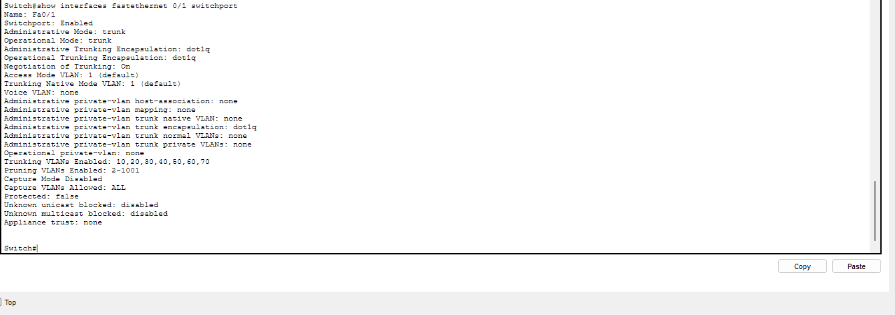
Issue 3: Trunk Link Down
One uplink interface was initially down because the physical link between the switches was not operational.
Resolution:
- Verified the physical connection
- Enabled the interface
- Verified both sides of the trunk
Verification:
show interfaces
show interfaces trunk
show cdp neighbors
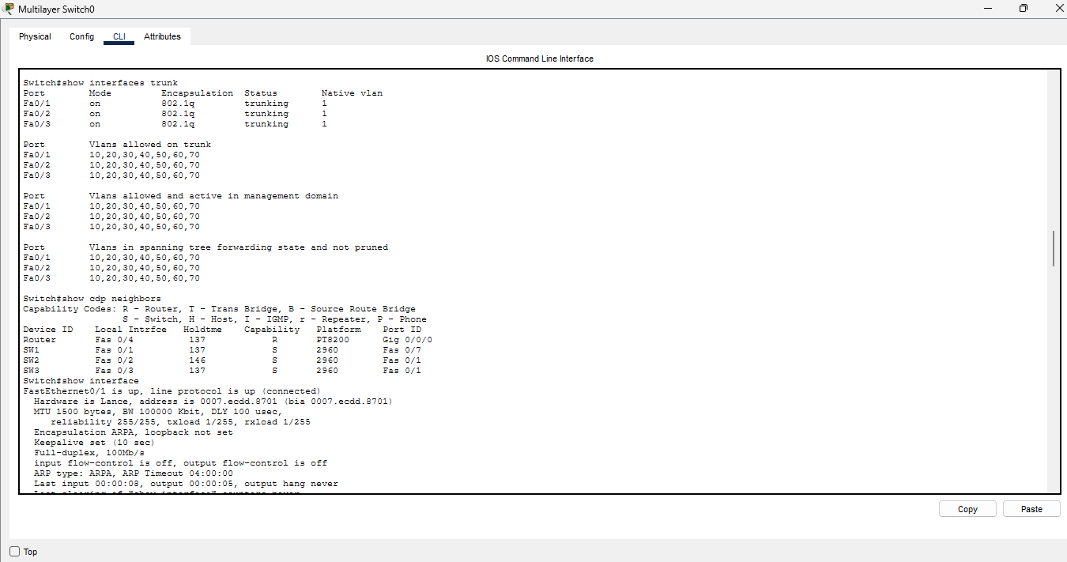
Issue 4: SSH Authentication Failure
SSH connectivity was initially successful at the transport level, but authentication failed.
Resolution:
The local administrative user account was recreated, and the VTY lines were configured to use local authentication.
Configuration:
username admin password <REDACTED>

line vty 0 4
login local
transport input ssh
Result:
Successful SSH login was achieved on SW1, SW2 and SW3.
Configuration Verification Commands
show vlan brief
show interfaces status
show interfaces trunk
show ip interface brief
show ip route
show ip access-lists
show spanning-tree
show cdp neighbors
show ip ssh
show running-config
show mac address-table dynamic
copy running-config startup-config
These commands were used throughout the implementation to verify VLAN membership, interface status, trunking, routing, ACL operation, Spanning Tree state, device discovery, SSH configuration and MAC address learning.
Limitations
The current Packet Tracer topology does not include a connected ISP or external WAN network. The router therefore provides internal routed connectivity to the enterprise network but does not currently provide a validated Internet connection.
NAT/PAT and Internet connectivity were not demonstrated because no external WAN/ISP device was connected to the router in the final topology.
Conclusion
The enterprise network was successfully designed and implemented in Cisco Packet Tracer using VLAN segmentation, Layer 3 switching, inter-VLAN routing, 802.1Q trunking, ACL-based security, SSH management and switch hardening.
Connectivity testing confirmed that the departmental VLANs could communicate with their respective gateways and that authorised departments could reach the server. Guest network isolation and server protection policies were validated using ACL counters and connectivity tests.
The access switches were securely managed using SSH and a dedicated Management VLAN. Unused switch ports were moved to VLAN 999 and administratively disabled.
The project also provided practical experience in troubleshooting native VLAN mismatches, incorrect switchport modes, trunk connectivity, Spanning Tree behaviour and SSH authentication problems.
Overall, the implementation demonstrates practical knowledge of enterprise switching, routing, segmentation, access control and secure network administration.
Appendix A — IP Addressing Summary
Administration
PC1: 192.168.15.2
PC2: 192.168.15.3
Gateway: 192.168.15.1
Finance
PC1: 192.168.15.34
PC2: 192.168.15.35
Gateway: 192.168.15.33
HR
PC1: 192.168.15.66
PC2: 192.168.15.67
Gateway: 192.168.15.65
IT
PC1: 192.168.15.98
PC2: 192.168.15.99
Gateway: 192.168.15.97
Guest
PC1: 192.168.15.130
PC2: 192.168.15.131
Gateway: 192.168.15.129
Server
Server: 192.168.15.162
Gateway: 192.168.15.161
Management
Core: 192.168.15.193

SW1: 192.168.15.194
SW2: 192.168.15.195
SW3: 192.168.15.196
Router Transit
Core: 192.168.15.225
Router: 192.168.15.226

